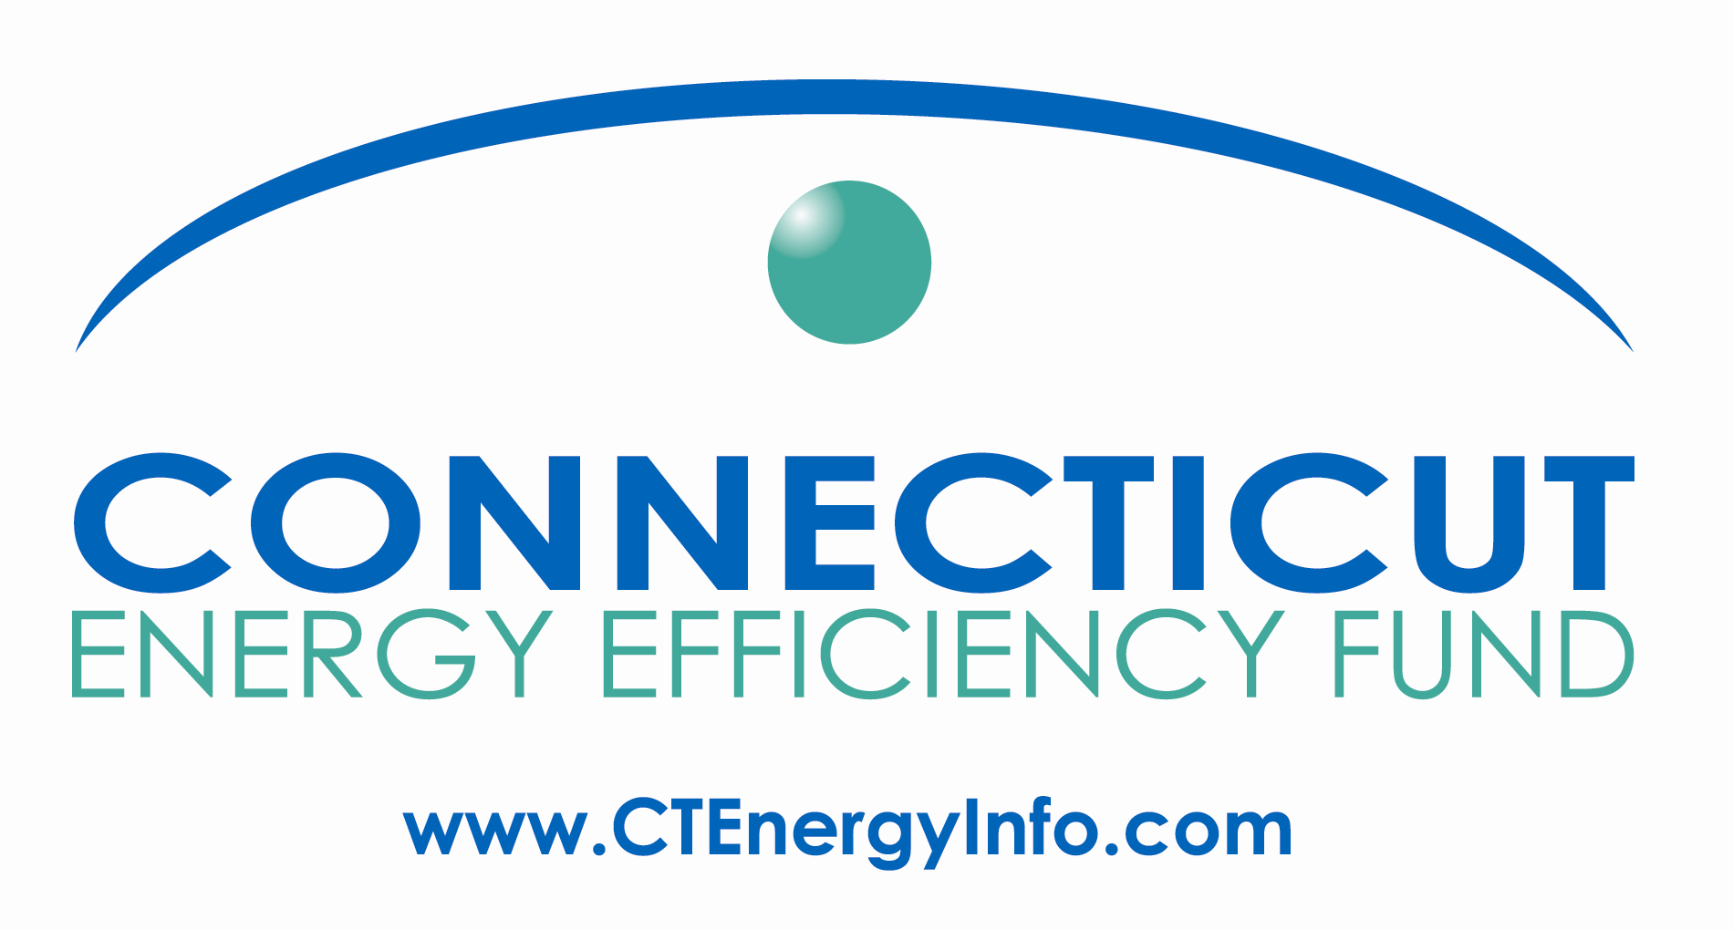

Agenda

Energy Efficiency Board
Residential/Home Energy Solutions Committee Meeting
December 7, 2010, 10:00 pm -12:00 Noon
Department of Public Utility Control
10 Franklin Square, New Britain, CT 06051

10:00
- Residential Financing update
Pilot status
Identification of new sources of capital
- Neighbor to Neighbor: Companies’ presentation of participation in program; update from Neighbor to Neighbor
- eeCommunities update, including coordination with other community programs
- 2011 program highlights and issues

10:50 Break

11:00
- Public Input
- HES
- Update on provision of customer usage data to HES vendors
- Vendor questions/concerns

